ASSIGNMENT 2

1. CONTAINER WITH MOST WATER :

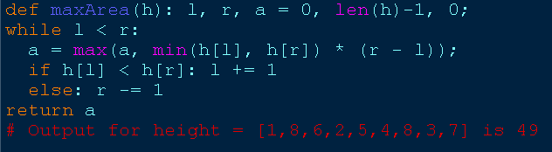

1. INTEGER TO ROMAN :

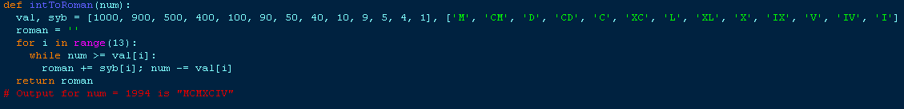

1. ROMAN TO INTEGER :

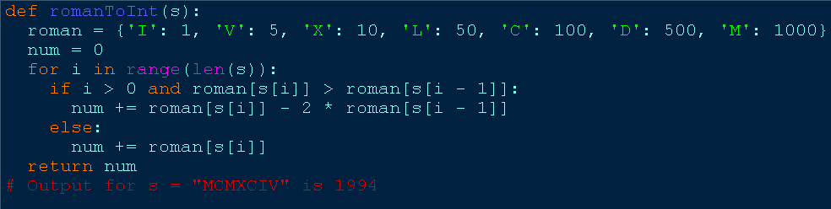

1. LONGEST COMMON PREFIX :

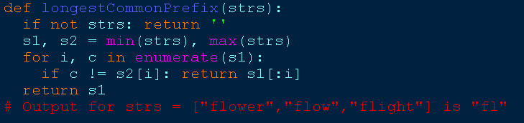

1. 3 SUM :

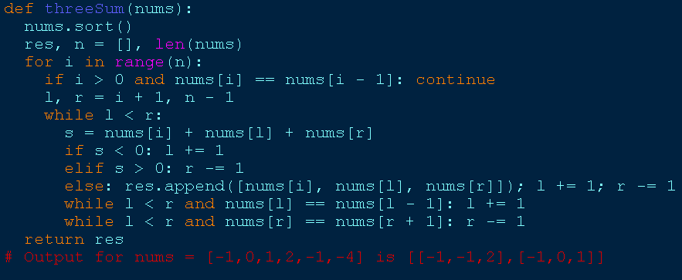

1. 3 SUM CLOSEST :

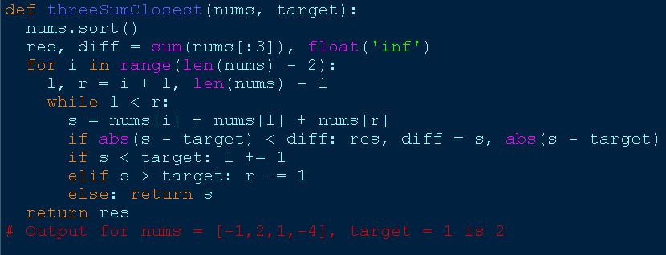

1. LETTER COMBINATIONS OF A PHONE :

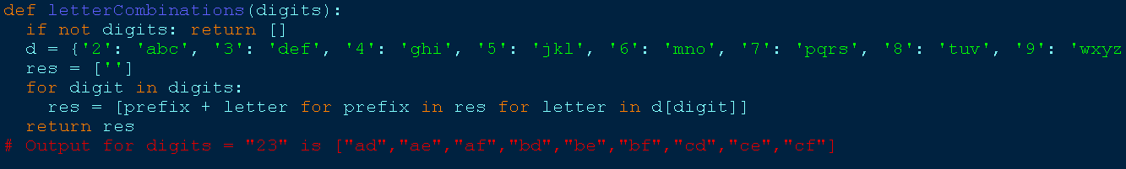

1. 4 SUM :

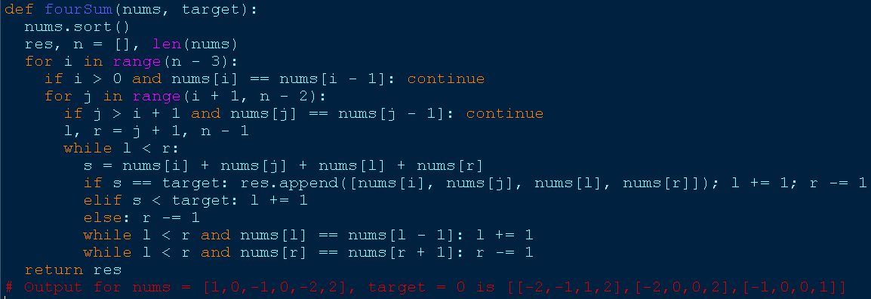

1. REMOVE NTH NODE FROM THE END OF THE LIST :

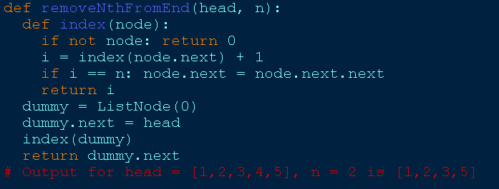

1. VALID PARENTHESIS :

